

ALZHEIMER’S DEMENTIA CLASSIFICATION USING SPONTANEOUS SPEECH AND MRI

CS6510 – PROJECT 1
REPORT

Submitted by
STUDENT NAME – REGISTER NUMBER

In partial fulfilment for the award of the degree of
POST GRADUATE PROGRAMME
INTERNATIONAL CENTRE FOR HIGHER EDUCATION AND RESEARCH
VIT BANGALORE

DECEMBER, 2023



BONAFIDE CERTIFICATE
Certified that this project report “PROJECT TITLE” is the bonafide record of work done by “STUDENT NAME – REGISTER NUMBER” who carried out the project work under my supervision.

Signature of the Supervisor Signature of Director

Dr. Pitchumani Angayarkanni S  Professor,  ICER  VIT Bangalore | Prof. Prema M  Director,  ICER  VIT Bangalore.
Evaluation Date:



ACKNOWLEDGEMENT

I express my sincere gratitude to our director of ICER Prof. Prema M. for their support and for providing the required facilities for carrying out this study.
I wish to thank my faculty supervisor(s), Guide Name, Designation, ICER for extending help and encouragement throughout the project. Without his/her continuous guidance and persistent help, this project would not have been a success for me.
I am grateful to all the members of ICER, my beloved parents, and friends for extending the support, who helped us to overcome obstacles in the study.

TABLE OF CONTENTS
CHAPTER NO. | TITLE | PAGE NO.
 | ABSTRACT
 | LIST OF FIGURES
 | LIST OF TABLES
1 | INTRODUCTION | 1
 | - ALZHEIMER’S DEMENTIA | 1
 | - STATISTICAL INFORMATION | 2
 | 1.3 CURRENT DIAGNOSIS METHODS | 3
2 | LITERATURE REVIEW | 3
3 | OBJECTIVE | 4
4 | PROPOSED METHODOLOGY | 5
5 | TOOLS AND TECHNIQUES | 6
6 | IMPLEMENTATION | 7
7 | RESULTS AND DISCUSSIONS | 14
8 | CONCLUSION | 15
9 | FUTURE ENHANCEMENT
10 | APPENDICES | 16
 | Appendix-1: Code – Full Code
 | Appendix-2: Plagiarism Report
11 | REFERENCES | 23
12 | WORKLOG | 24

ABSTRACT
Guidelines:
Times New Roman 12
A brief summary of the research question, methodology, results, and conclusion.

Alzheimer’s Disease is the most common form of dementia which initially destroys the memory and finally progresses to death. This irreversible disease is mostly found among older people. The latest innovations in the multimodal neuroimaging data made it possible to detect the disease in life which was a major breakthrough in neuroscience. However, the larger degree of similarity between the brain images was the major challenge in the diagnosis. The Deep Learning technique has gained excellent results on image classification among the present researches. Hence it is utilized for the classification of brain images among very mildly demented, mildly demented, moderately demented, non-demented. The transfer learning approach has been taken up for the classification process by which four pre-trained networks, namely Densenet169, Resnet50, InceptionV3, VGG16 are modified and trained for 6400 images. Detecting Alzheimer's disease based on speech data from the patients can aid non-invasive, cost-effective, real-time early diagnostic and repetitive monitoring in minimum time and effort using machine learning (ML) classification approaches. This project aims to predict early AD diagnosis and evaluate stages of AD through acoustic features and image. Evaluation of the proposed AD prediction and AD stages classification models using machine learning and deep learning techniques.

LIST OF FIGURES

Figure No. Figure Name Pg. No.
Fig. 4.1 Methodology 5
Fig. 6.1 Architecture of ResNet50 8
Fig. 6.2 Architecture of VGG16 8
Fig. 6.3 Architecture of InceptionV3 9
Fig. 6.4 Architecture of DenseNET169 9

LIST OF TABLES

Table No. Table Name Pg. No.
Table. 7.1 Results of Deep Learning Models 14
Table 7.2 Results of Machine Learning Models 14

CHAPTER 1
INTRODUCTION
Guidelines:
Sub headings starts with 1.1
Time New Roman 14
Content inside each heading Times New Roman 12
- Introduce the research topic.
- Present the background and the rationale for the research.
- State the research questions and/or hypotheses.
- Define the scope and limitations of the research.
  - ALZHEIMERS DEMENTIA

Alzheimer's disease is a progressive brain disorder that affects memory, thinking, and behaviour. It is the most common cause of dementia, a group of brain disorders that cause a decline in cognitive abilities.

The disease typically begins with mild memory loss and difficulty performing familiar tasks, such as following a recipe or balancing a check book. As it progresses, people with Alzheimer's may have trouble communicating, organizing their thoughts, and recognizing people and places. They may also experience personality changes, agitation, and depression.

The exact cause of Alzheimer's disease is not fully understood, but it is believed to be related to a combination of genetic, environmental, and lifestyle factors. There is no cure for Alzheimer's disease, but treatments are available that can help manage symptoms and improve quality of life. Early detection and diagnosis are important for getting the most benefit from these treatments.

  - STATISTICAL INFORMATION

According to the Alzheimer's and Related Disorders Society of India (ARDSI), there are currently an estimated 5.3 million people living with dementia in India. This number is expected to double by 2030, and triple by 2050.

While there is limited data available on the prevalence of Alzheimer's disease specifically in India, studies suggest that dementia is a growing health concern in the country. One study published in the Journal of Alzheimer's Disease in 2018 estimated that the prevalence of dementia in India was 4.4 million, with Alzheimer's disease accounting for the majority of cases.

Risk factors for Alzheimer's disease in India may include a high prevalence of diabetes and cardiovascular disease, as well as lower levels of education and literacy in some regions.

It is important to note that dementia is often underdiagnosed and underreported in India, due to a lack of awareness and resources for diagnosis and treatment. As such, the true prevalence of Alzheimer's disease and other forms of dementia in India may be higher than current estimates suggest.

1.3 CURRENT DIAGNOSIS METHODS
Early detection and diagnosis are important for getting the most benefit.
At present, there is no single test that can definitively diagnose Alzheimer's disease. Diagnosis is typically based on a combination of factors, including medical history, cognitive tests, and imaging studies.

The process usually begins with a thorough medical evaluation to rule out other possible causes of cognitive impairment, such as vitamin deficiencies, thyroid problems, or medication side effects. Doctors may also conduct cognitive tests to assess memory, language, and problem-solving skills. These tests can help identify patterns of cognitive decline and track changes in cognitive function over time. Imaging studies, such as magnetic resonance imaging (MRI) or positron emission tomography (PET) scans, can also provide information about the structure and function of the brain, and may help identify characteristic patterns of brain changes associated with Alzheimer's disease. In some cases, doctors may also perform genetic testing to identify the presence of certain genes that are associated with an increased risk of developing Alzheimer's disease.

Ultimately, a diagnosis of Alzheimer's disease is made by considering all of these factors together and ruling out other possible causes of cognitive impairment. Early diagnosis is important for providing appropriate treatment and support, and for planning for the future.

- LITERATURE REVIEW
Guideline:
- Summarize the current state of knowledge on the topic.
- Discuss relevant theories, models, and previous studies.
- Identify gaps in the existing literature that the project aims to fill.
This section talks about the other previous works on prediction of Alzheimer Dementia. The journal [1] uses a hybrid-based AI-based model that includes the combination of both transfer learning (TL) and permutation-based machine learning (ML) voting classifier in terms of two basic phases. In the first phase of implementation, it comprises two TL-based models: namely, DenseNet-121 and Densenet-201 for features extraction, whereas in the second phase of implementation, it carries out three different ML classifiers like SVM, Naïve base and XGBoost for classification purposes. The final classifier outcomes are evaluated by means of permutations of the voting mechanism. The proposed model achieved accuracy of 91.75%, specificity of 96.5%, and an F1-score of 90.25.
In Journal [2], the ADReSS dataset, a dataset balanced by gender and age, was used to automatically classify AD from spontaneous speech. The performance of five classifiers, as well as a convolutional neural network and long short-term memory network, was compared when trained on audio features and text features. The same audio and text features were used to train five regression models to predict the Mini-Mental State Examination score for each patient, a score that has a maximum value of 30. The top-performing classification models were the support vector machine and random forest classifiers trained on BERT embedding, which both achieved an accuracy of 85.4% on the test set. The performance on both tasks illustrates the feasibility of using speech to classify AD and predict neuropsychological scores.
Paper [3] aims to do the AD recognition task which performs a binary classification of speech samples into AD and non-AD classes; The segmented dataset contains 1,955 speech segments from 78 non-AD subjects and 2,122 speech segments from 78AD subjects. Feature extraction was performed on the speech segments using the openSMILEv2.1toolkit. Linear Discriminant Analysis(LDA), Random Forests(RF) , Support Vector Machines, and leave-one-subject out(LOSO) cross-validation , KNN setting was adopted. The classifiers were trained and tested to predict whether a speech segment was uttered by a non-AD or AD patient where it was found that DT gave the highest and most stable accuracy and features gave a higher accuracy of 0.625 for acoustic features.
- OBJECTIVE
To build an efficient model to perform the classification of Alzheimer’s dementia through Imaging and Speech Data. Both image and speech data can be collected in a non-invasive way.
There is growing evidence that changes in speech and language patterns can occur in the early stages of Alzheimer's disease, even before clinical symptoms appear. Similarly, brain imaging techniques can detect changes in brain structure and function before symptoms appear. The main objective of the project is to make the diagnosis of the disease by utilizing spontaneous speech and MRI images.
- Analyzing the image dataset available and using pre-trained algorithms to classify the data efficiently.
- Perform Exploratory Data Analysis on meta data of speech
- Work with speech dataset and classify the data into demented and non-demented by using the machine learning algorithm.

- PROPOSED METHODOLOGY
- Describe the research design and the rationale for the chosen methodology.
- Outline the data sources, collection methods, and any instruments used.
- Explain the data analysis procedures.
- Discuss any steps taken to ensure validity and reliability.

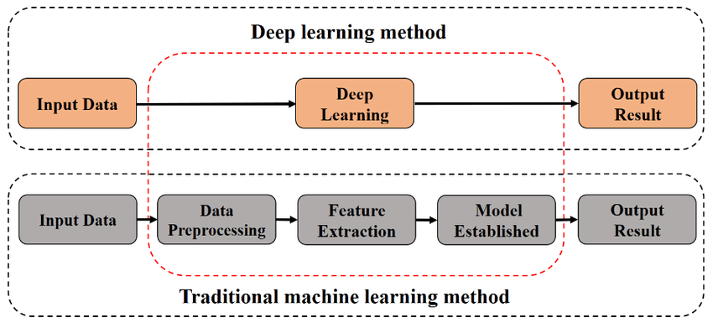

Fig 4.1 Methodology

This project aims to classify MRI brain scans of Alzheimer patients using deep learning techniques while utilizing the machine learning models to predict Alzheimer’s in speech dataset. The MRI images were sourced from kaggle which has 6400 images all shaped in 128x128x3.They were divided into 4 classes of images namely; very midly demented, mild demented, moderate demented and no demented. Pretrained models were utilized to predict the images into the 4 different classes.
While using the spontaneous speech data which was sourced from Dementia Bank, Acoustic feature MFCC (Mel-Frequency Cepstral Coefficients) was extracted and pre-processing techniques like train test split and Standardisation was carried out. Then machine learning models like SVM, Naïve Bayes, Linear Regression, Random Forest and ensemble learning techniques were utilized and accuracy, confusion matrix was used to find the efficiency of the model.

- TOOLS AND TECHNIQUES
There are several tools commonly used for deep learning classification, depending on the specific application and the level of expertise of the practitioner. Here are some popular tools used for deep learning classification:

1. TensorFlow: TensorFlow is an open-source deep learning framework developed by Google. It is widely used for classification tasks, including image classification, natural language processing, and speech recognition.

2. Keras: Keras is a high-level deep learning framework that can be used with TensorFlow or Theano as the backend. It provides an easy-to-use API for building and training deep learning models, including classification models.

3. Scikit-learn: Scikit-learn is a popular machine learning library for Python that includes many algorithms for classification tasks, including deep learning algorithms such as multi-layer perceptrons (MLPs).

4. MATLAB: It is a programming language and environment that includes many deep learning tools and features, including support for popular deep learning frameworks like TensorFlow and PyTorch.

5. Librosa: It is a Python library for audio and music signal processing. It provides a set of tools for audio analysis, including feature extraction, spectrogram and chromagram computation, audio playback and visualization, and time-frequency signal processing. Librosa is designed to make it easy for developers to work with audio data in Python, and it is widely used in music information retrieval, audio classification, and speech processing applications. It is built on top of other Python libraries such as NumPy and SciPy, and it is free and open-source software.

6 IMPLEMENTATION
Guideline:
Elaborate the techniques/algorithms/models used
6.1 ALZHEIMERS CLASSIFICATION USING MRI
6.1.1. ABOUT THE DATASET:
The Data is hand collected from various websites with each and every labels verified and sourced Kaggle.
THE 4 CLASSES:
VERY MILD DEMENTIA:2240
MILD-DEMENTIA: 896
MODERATE DEMENTIA: 64
NON DEMENTIA: 3200
IMAGE SHAPE: 128X128X3
NO OF ROWS: 6400

6.1.2. PREPROCESSING
Pre-processing is just as important in deep learning as it is in other areas of machine learning and data analysis. In fact, it can be argued that it is even more critical in deep learning due to the complexity of the models and the large amount of data typically involved.
Data augmentation is a technique of artificially increasing the training set by creating modified copies of a dataset using existing data. It includes making minor changes to the dataset or using deep learning to generate new data points. Techniques include resizing, zoom, rotating, cropping, padding, etc. It helps to address issues like overfitting and data scarcity, and it makes the model robust with better performance.

6.1.3. MODELS
Resnet50
Deep residual networks like the popular ResNet-50 model is a convolutional neural network (CNN) that is 50 layers deep. A residual neural network (ResNet) is an artificial neural network (ANN) of a kind that stacks residual blocks on top of each other to form a network. It can work with different input size and designed to overcome problem of vanishing gradient by using residual connections. 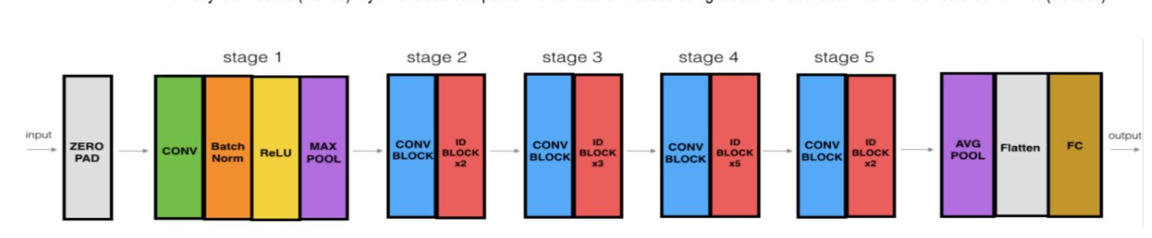
Fig 6.1 Architecture of Resnet50

- Architecture includes
  - It contains an initial convolutional layer, followed by a max pooling layer.
  - Four sets of convolutional layers, with each set containing several residual blocks.
  - A global average pooling layer.
  - A fully connected layer with a softmax activation function.
VGG16
- VGG Net is a Convolutional Neural Network architecture proposed by Karen Simonyan and Andrew Zisserman from the University of Oxford in 2014.
- Focuses on the effect of the convolutional neural network depth on its accuracy. The famous paper “Very Deep Convolutional Networks for Large-Scale Image Recognition” made the term deep viral. It was the first study that provided undeniable evidence that simply adding more layers increases the performance.
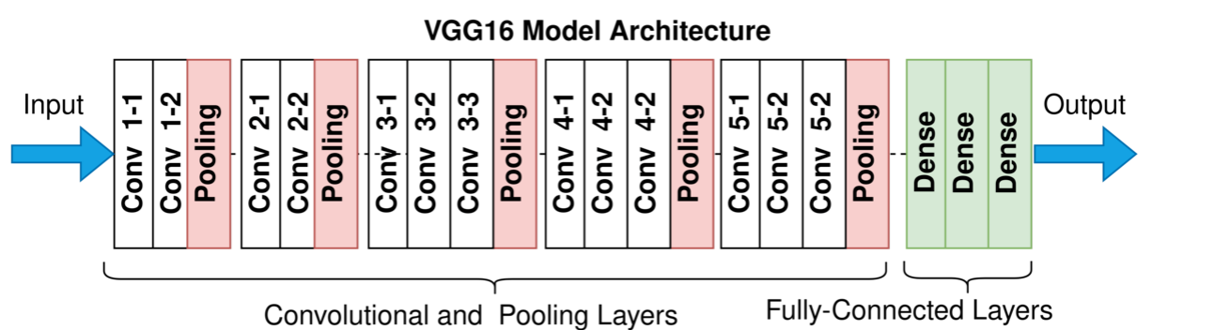
Fig 6.2 Architecture of VGG16

INCEPTION V3
- Inception-v3 is a pre-trained convolutional neural network that is 48 layers deep, which is a version of the network already trained on more than a million images from the ImageNet database. This pre-trained network can classify images into 1000 object categories, such as keyboard, mouse, pencil, and many animals.
- As a result, the network has learned rich feature representations for a wide range of images. The model extracts general features from input images in the first part and classifies them based on those features in the second part.
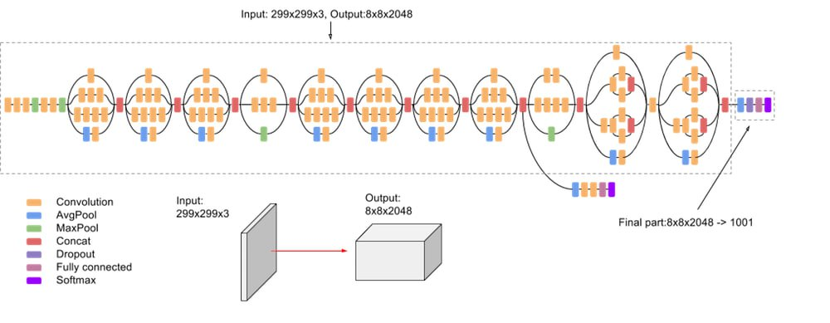
Fig 6.3 Architecture of Inception V3

DENSENET169
- DenseNet-169 was chosen because despite having a depth of 169 layers it is relatively low in parameters compared to other models, and the architecture handles the vanish gradient problem well.
- For each layer, the feature maps of all preceding layers are used as inputs, and its own feature-maps are used as inputs into all subsequent layers. DenseNet have several compelling advantages: they alleviate the vanishing-gradient problem, strengthen feature propagation, encourage feature reuse, and substantially reduce the number of parameters.
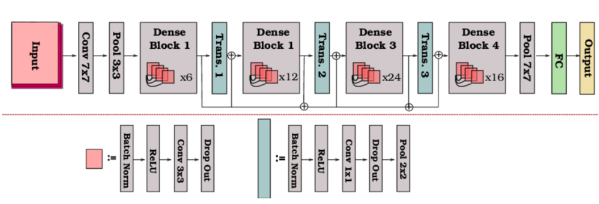
Fig 6.4 Architecture of Densenet169

6.1.4. EVALUATION
Evaluation is a critical step in any deep learning project as it helps to assess the performance of the model and identify areas for improvement. There are several evaluation metrics that are commonly used in deep learning, depending on the task and the type of model being evaluated.
1. Accuracy: Accuracy is the most commonly used evaluation metric for classification tasks. It measures the proportion of correct predictions made by the model.
2. Precision and Recall: Precision and Recall are evaluation metrics used in binary classification tasks. Precision measures the proportion of true positives among all positive predictions, while recall measures the proportion of true positives among all actual positive cases.
3. F1 Score: The F1 score is a weighted average of precision and recall that combines the two metrics into a single score. It is often used in binary classification tasks where precision and recall are both important.
4. Area Under the Curve (AUC): The AUC is a metric that measures the overall performance of a classification model across all possible classification thresholds.

6.2. SPEECH DATA CLASSIFICATION
6.2.1. ABOUT THE DATASET
Source: Dementia Bank
License: Becker, J. T., Boller, F., Lopez, O. L., Saxton, J., & McGonigle, K. L. (1994). The natural history of Alzheimer's disease: description of study cohort and accuracy of diagnosis. Archives of Neurology, 51(6), 585-594.
NIA AG03705 and AG05133
The dataset contains the following files:
- Full_wave_enhanced_audio (contains the audio recordings after noise removal.)
- Normalised_audio-chunks (contains the .wav files which are extracted from the audio recordings after applying voice activity detection.)
- cc_meta_data.txt (age, gender and MMSE score.)
6.2.2. EXPLORATORY DATA ANALYSIS
EDA (Exploratory Data Analysis) is an essential step in any machine learning project, including Alzheimer's disease classification. EDA involves exploring and visualizing the data to gain insights and identify patterns that can inform the model building process. In the context of Alzheimer's disease classification, EDA involves exploring the demographic and clinical data of the patients.
It was found that Alzheimer’s usually occurs in the age group above 50 and that women are more likely to be affected by Alzheimers dementia. The dataset we had has more data with MMSE square between 25-30. The dataset has almost 59% no demented patients and rest are demented.
6.2.3. FEATURE EXTRACTION
The spontaneous speech data are in the form of wav files. Therefore, using the Librosa library we were able to build a function that concatenates the mean, standard deviation and skewness of the MFCC (Mel frequency Cepstral coefficient). MFCC is a popular feature extraction technique used in speech processing and analysis. It is used to represent the spectral characteristics of speech signals, are particularly effective for speech data because they can capture important acoustic features of speech, such as the formant frequencies, which are related to the shape of the vocal tract and are critical for distinguishing different phonemes. MFCCs are based on the Mel scale, which is a perceptual scale that is more closely related to the way humans perceive pitch than the linear frequency scale.
6.2.4. PRE-PROCESSING
Preprocessing is a critical step in any machine learning project, including classification tasks such as Alzheimer's disease classification.
Train-test split involves dividing the available data into two subsets: a training set and a testing set. The training set is used to train the machine learning model, while the testing set is used to evaluate the performance of the trained model. This technique is essential for preventing overfitting and ensuring that the model generalizes well to new data.
Standard scaling, also known as Z-score normalization, is a preprocessing technique used to scale the data to have zero mean and unit variance. Standard scaling is applied separately to each feature in the data, and it involves subtracting the mean of the feature and dividing by its standard deviation.

6.2.5. MODELS
After having performed data preprocessing, we apply classification models, namely
Random Forest
- Random Forest is an ensemble learning algorithm that is commonly used for classification and regression tasks in machine learning.
- Random Forest algorithm is based on probability.
- To make a prediction on new data, the random forest algorithm first runs each data point through each of the individual decision trees in the forest, and then takes the majority vote of the predicted class (in classification tasks) or the average prediction (in regression tasks).
Support Vector Machine
- Support Vector Machines (SVMs) are a type of supervised learning algorithm used for classification and regression tasks. The basic idea behind SVMs is to find a hyperplane or a set of hyperplanes in a high-dimensional space that can best separate the data into different classes.
- In the case of classification, SVMs aim to find a decision boundary that maximizes the margin between the classes.

K-Nearest Neighbor
- KNN is a simple yet effective algorithm that does not make any assumptions about the underlying distribution of the data.
- The algorithm works by calculating the distance between the test example and each training example in the feature space. K-Nearest Neighbors (KNN) is a type of supervised machine learning algorithm that is used for both classification and regression tasks.
- The value of K is a hyper parameter that needs to be tuned for each specific problem, and a larger value of K will result in a smoother decision boundary but may also introduce more bias.
Decision Tree:
- Decision tree is a supervised machine-learning algorithm that is commonly used for classification and regression tasks.
- It is a type of predictive modeling algorithm that makes predictions by learning simple decision rules from the input features of the training data(by recursively splitting training data into subsets based on input features).

Naïve Bayes
- Naive Bayes is a type of probabilistic machine learning algorithm that is commonly used for classification tasks.
- To train a Naive Bayes classifier, the algorithm first calculates the prior probabilities of each class based on the training data.
- Then, for each feature, it calculates the conditional probability of that feature given each class. Finally, it applies Bayes' theorem to calculate the posterior probabilities of each class given the evidence (the features of the instance).

Ensemble Model
- Hard Voting: In hard voting, the ensemble model makes a final prediction based on the majority vote of the individual models. Hard voting works best when the individual models have similar levels of accuracy and the classes are well-balanced.
- Soft Voting: In soft voting, the ensemble model makes a final prediction based on the weighted average of the individual models' predicted probabilities for each class. Soft voting is useful when the individual models have different levels of confidence in their predictions, and it allows the ensemble model to take into account the probability of each class rather than just the number of votes.

6.2.6. EVALUATION
1.Accuracy: Accuracy is the most commonly used evaluation metric for classification tasks. It measures the proportion of correct predictions made by the model.
2. Precision and recall: These metrics are important for evaluating the performance of models in cases where the data is imbalanced. Precision measures the proportion of true positives among all positive predictions, while recall measures the proportion of true positives among all actual positive cases.
3. F1 score: It provides a balanced measure of the model's performance and is particularly useful for evaluating models in cases where both precision and recall are important.
Table Representing the comparison of the Performance Metrics

7. RESULTS AND DISCUSSIONS
Guideline:
RESULTS
- Present the findings of the research.
- Include data in the form of tables, graphs, and charts.
- Describe any patterns, trends, or significant observations.

Discussion
- Interpret the results and discuss their implications.
- Compare the findings with those from the literature review.
- Consider the meaning of the results in the context of the research questions.

For the image dataset, when classifying the MRI scans into 4 classes, the best results are found to be from DenseNet169. This could be because its dense connectivity pattern and feature reuse mechanisms allow for efficient use of network parameters, leading to improved performance and reduced overfitting. InceptionV3 gave less accuracy and there could be many factors that may have affected the performance of InceptionV3, such as preprocessing techniques, model architecture modifications, or specific characteristics of the data.
MODEL | ACCURACY
DenseNet169 | 94%
ResNet50 | 87%
VGG16 | 89%
InceptionV3 | 60%  Table 7.1 Results of Deep learning models

For the speech dataset, model results are much lower than necessary for clinical use, but prove that machine learning models are successful in learning the difference in the audio of AD patients. Given the limited size of the dataset, results are lower than what can be expected from a larger, more standardized dataset. Ensemble Model using Random Forest, Naive Bayes and KNN gives the highest accuracy
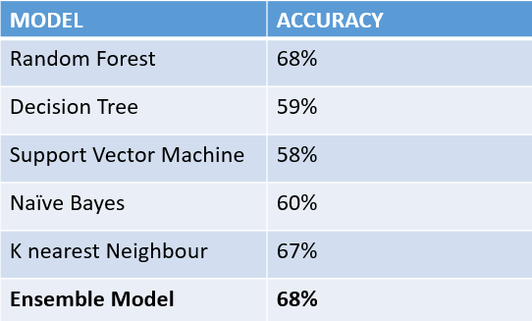
Table 7.2 Results of Machine learning models

8.CONCLUSION
GUIDELINE
- Summarize the main findings and their relevance.
- State the conclusions drawn from the research.
- Discuss the potential impact on the field and any practical applications.
- In conclusion, the classification of dementia using speech and MRI scans shows promising results. Both modalities provide complementary information for the accurate detection and diagnosis of different types of dementia.
- Speech analysis allows for the identification of subtle changes in language patterns, while MRI scans provide information on structural and functional brain changes.
- The integration of these two modalities can improve diagnostic accuracy and enable early detection of dementia, allowing for timely intervention and management.
- However, further research is needed to improve the specificity and sensitivity of these classification methods, as well as to evaluate their practicality and applicability in clinical settings.

9. FUTURE ENHANCEMENT
GUIDELINE:
- Suggest areas for future research.

10.APPENDICIES
10.1 FULL CODE

BATCH_SIZE = 32
IMG_SIZE = (128, 128)
SEED = 0

directory = '/content/drive/MyDrive/Dataset'

train_dataset = image_dataset_from_directory(directory=directory,
label_mode='categorical',batch_size=BATCH_SIZE,image_size=IMG_SIZE,shuffle=True,validation_split=0.2,subset='training',seed=SEED)

full_validation_dataset = image_dataset_from_directory(directory=directory,label_mode='categorical',batch_size=BATCH_SIZE,image_size=IMG_SIZE, shuffle=True,validation_split=0.2,subset='valition',seed=SEED)

data_augmentation = data_augmentar()
assert(data_augmentation.layers[0].name.startswith('random_rotation'))
assert(data_augmentation.layers[0].factor == (-0.15, 0.15))
assert(data_augmentation.layers[1].name.startswith('random_zoom'))
assert(data_augmentation.layers[1].height_factor == (-0.3, -0.1))
base_model_3 = VGG16(input_shape=(128,128,3),
include_top=False,
weights="imagenet")
for layer in base_model_3.layers:
layer.trainable= False
from keras.layers import Flatten,Dense
from keras.models import Model

x=Flatten()(base_model_3.output)
x=Dense(4098,activation="relu")(x)
x=Dense(4098,activation="relu")(x)
x=Dense(1000,activation="relu")(x)
x=Dense(4,activation="softmax")(x)

model3= Model(inputs=base_model_3.input,outputs=x)

model3.compile(optimizer='adam',
loss='categorical_crossentropy',
metrics=['accuracy',
tf.keras.metrics.AUC(),
tf.keras.metrics.Precision(),
tf.keras.metrics.Recall(),
])

# Train your model with mixed precision
history = model3.fit(train_dataset,
validation_data=validation_dataset,
steps_per_epoch=len(train_dataset),
epochs = 20,
verbose=1)

result = model3.evaluate(train_dataset)
train_loss = result[0]
train_accuracy = result[1]
train_AUC = result[2]
train_pre = result[3]
train_rec = result[4]

print(f'Train Loss = {train_loss}')
print(f'Train Accuracy = {train_accuracy}')
print(f'Train AUC = {train_AUC}')
print(f'Train Precision = {train_pre}')
print(f'Train Recall = {train_rec}')

SCREENSHOTS:
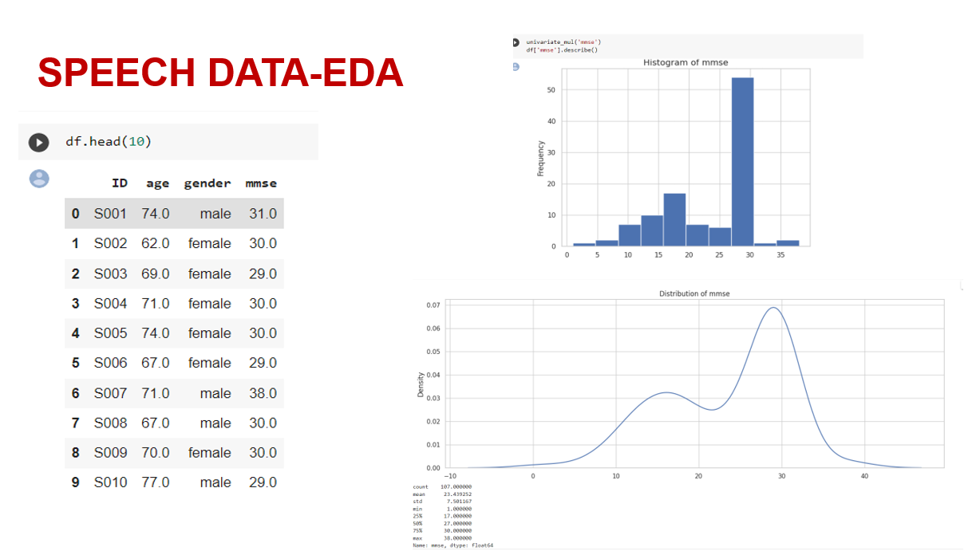
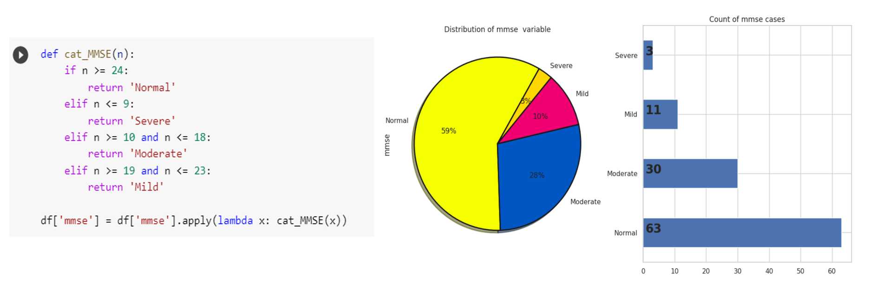
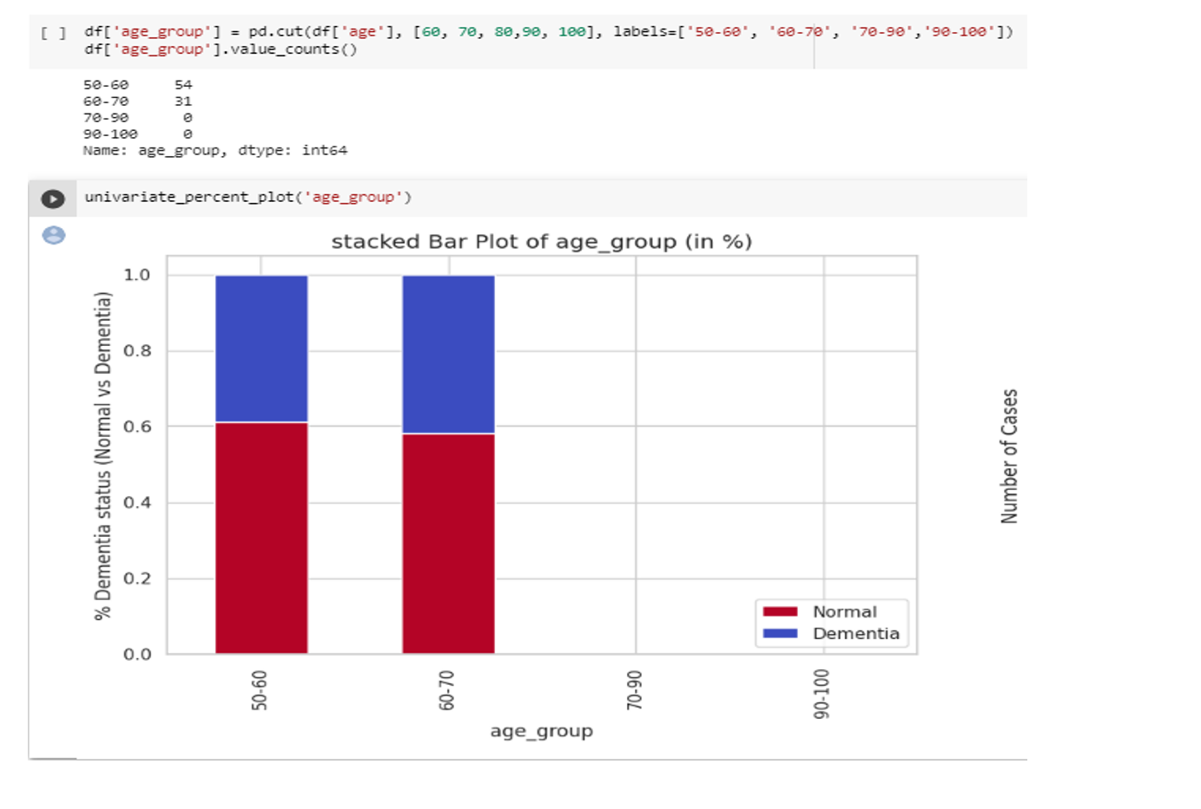
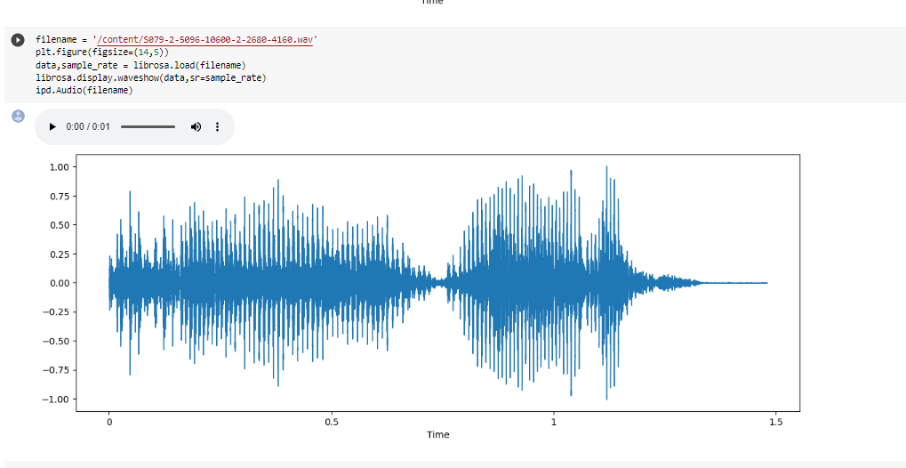
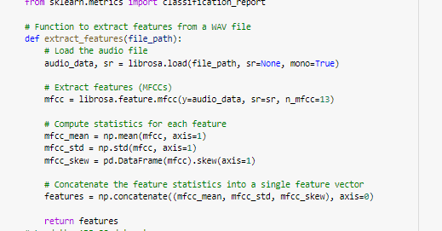
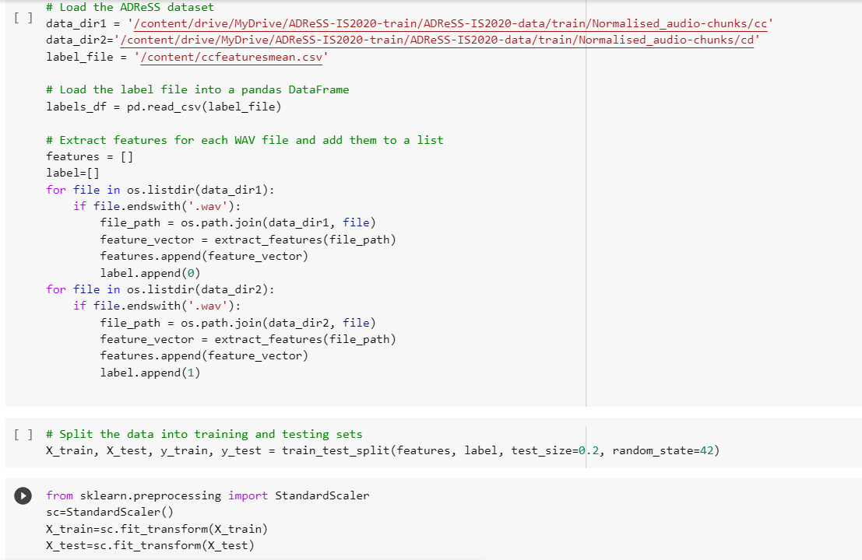
DECISION TREE:
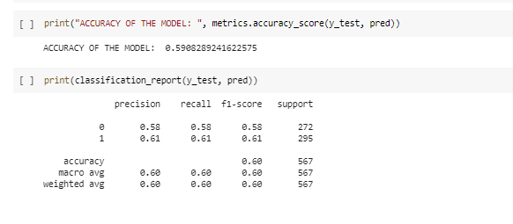
RANDOM FOREST:
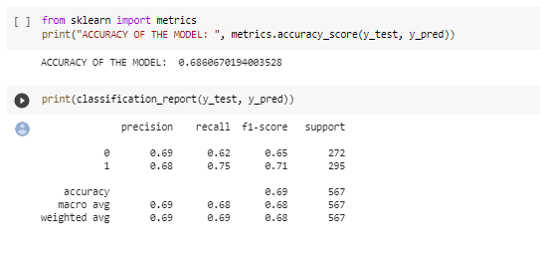
SUPPORT VECTOR CLASSIFICATION:
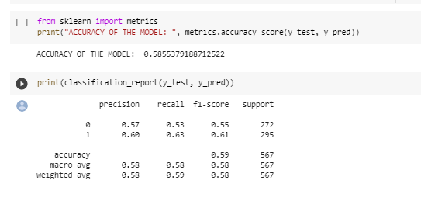
NAÏVE BAYES:
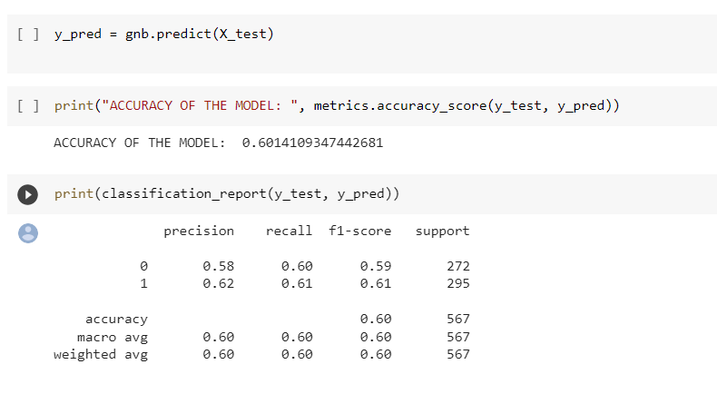
KNN:
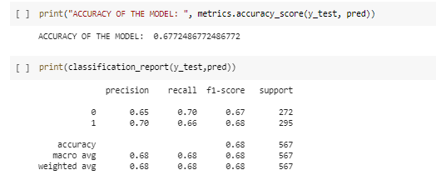
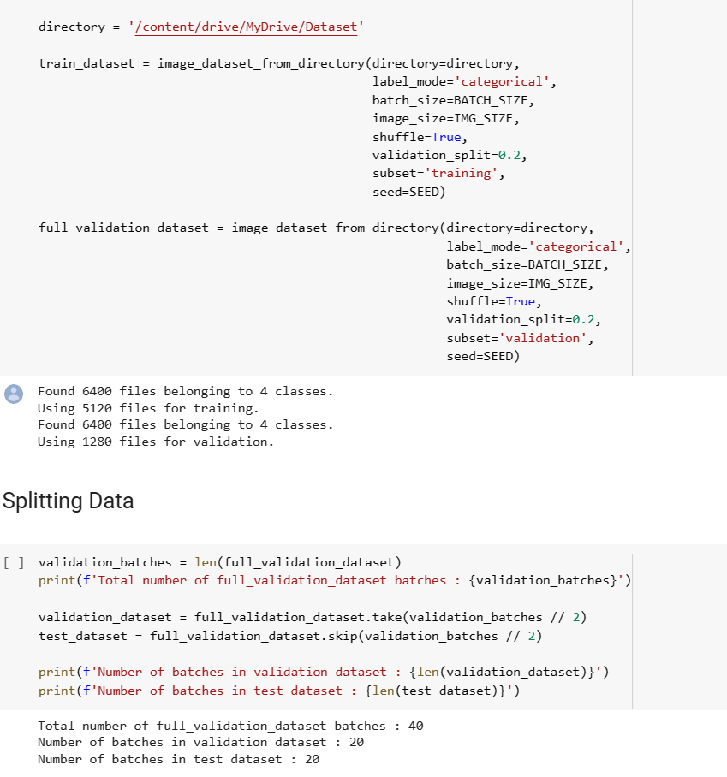

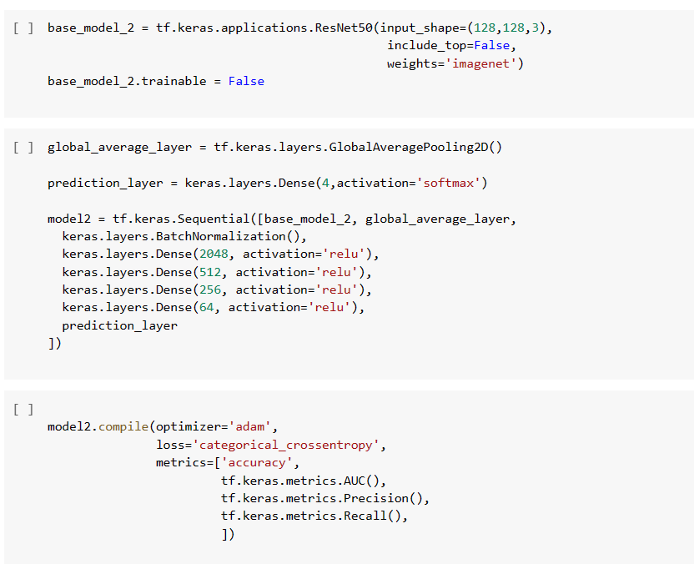

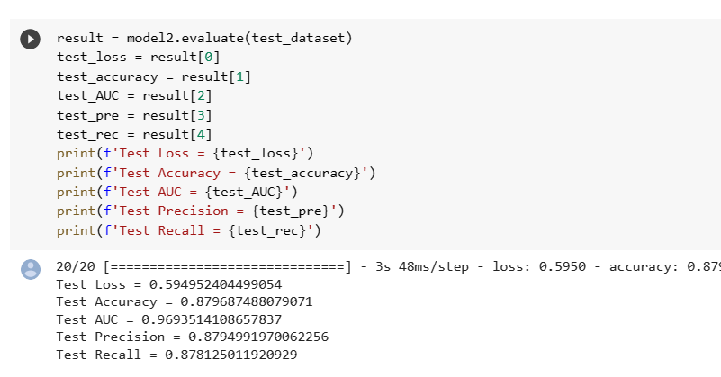

10.2 PLAGIARISM REPORT

11. REFERENCES
Journal References (APA FORMAT):
[1] Sharma, S., Gupta, S., Gupta, D., Altameem, A., Saudagar, A. K. J., Poonia, R. C., & Nayak, S. R. (2022). HTLML: Hybrid AI Based Model for Detection of Alzheimer’s Disease. Diagnostics, 12(8), 1833
[2] Haulcy, R'mani, and James Glass. "Classifying Alzheimer's disease using audio and text-based representations of speech." Frontiers in Psychology 11 (2021): 624137.
[3] Luz, S., Haider, F., de la Fuente, S., Fromm, D., & MacWhinney, B. (2020). Alzheimer's dementia recognition through spontaneous speech: The ADReSS challenge. arXiv preprint arXiv:2004.06833.
Web References:
1.MFCC extraction technique: MFCC Technique for Speech Recognition - Analytics Vidhya
2.Alzheimer classification using image: https://devpost.com/software/classification-of-alzheimer-s-disease-from-speech-data
3.Performance evaluation in deep learning: Performance Evaluation of Deep Learning Algorithms in Biomedical Document Classification | IEEE Conference Publication | IEEE Xplore
4.Preprocessing techniques for medical data: Medical Image Pre-Processing with Python | by Esma Sert | Towards Data Science

12.WORKLOG
ATTACH THE WORKLOG SHEET DULY SIGNED EACH DAY BY THE STUDENT AND GUIDE
Day | Date | Task Done
Day 1 | 15/02/2023 | Project domain discussion
Day 2 | 16/02/2023 | Domain Research
Day 3 | 17/02/2023 | Domain Research
Day 4 | 20/02/2023 | Domain Research
Day 5 | 21/02/2023 | Project title finalization
Day 6 | 22/02/2023 | Collecting Study materials
Day 7 | 23/02/2023 | Collecting Study materials
Day 8 | 24/02/2023 | Going through research journals
Day 9 | 27/02/2023 | Going through research journals
Day 10 | 28/02/2023 | Going through research journals
Day 11 | 1/03/2023 | Discussion project architecture
Day 12 | 2/03/2023 | Discussion project architecture
Day 13 | 3/03/2023 | Collecting Speech Dataset
Day 14 | 6/03/2023 | Collecting Image Dataset
Day 15 | 7/03/2023 | Analyzing the Dataset available
Day 16 | 8/03/2023 | Pre-processing the image dataset
Day 17 | 9/03/2023 | Pre-processing the image dataset
Day 18 | 10/03/2023 | Pre-processing the image dataset
Day 19 | 13/03/2023 | Working on Data Augmentation Techniques
Day 20 | 14/03/2023 | Working on Data Augmentation Techniques
Day 21 | 15/03/2023 | Model 1
Day 22 | 16/03/2023 | Model 2
Day 23 | 17/03/2023 | Model 3
Day 24 | 20/03/2023 | Model 4
Day 25 | 21/03/2023 | Working on getting better accuracy
Day 26 | 22/03/2023 | Working on getting better accuracy
Day 27 | 23/03/2023 | Prediction using the model
Day 28 | 24/03/2023 | Completed deep learning models for Image Dataset
Day 29 | 27/03/2023 | Analysing the speech dataset
Day 30 | 28/03/2023 | Finalizing the approach for speech data
Day 31 | 29/03/2023 | Exploratory data analysis using speech data
Day 32 | 30/03/2023 | Exploratory data analysis using speech data
Day 33 | 31/03/2023 | Exploratory data analysis using speech data
Day 34 | 03/04/2023 | Feature extraction
Day 35 | 04/04/2023 | Feature extraction
Day 36 | 5/04/2023 | Feature extraction
Day 37 | 6/04/2023 | Pre-processing the data
Day 38 | 6/04/2023 | Pre-processing the data
Day 39 | 7/04/2023 | Determine what models to utilize
Day 40 | 10/04/2023 | Model Building
Day 41 | 11/04/2023 | Model Building
Day 42 | 12/04/2023 | Model Building
Day 43 | 13/04/2023 | Comparing the models for best results
Day 44 | 14/04/2023 | Completed the classification using Speech data
Day 45 | 17/04/2023 | Working on final review presentation
Day 46 | 18/04/2023 | Working on final review presentation
Day 47 | 19/04/2023 | Working on final review presentation
Day 48 | 20/04/2023 | Working on Report
Day 49 | 21/04/2023 | Working on Report
Day 50 | 24/04/2023 | Working on Report

